Entity Relationship Diagram

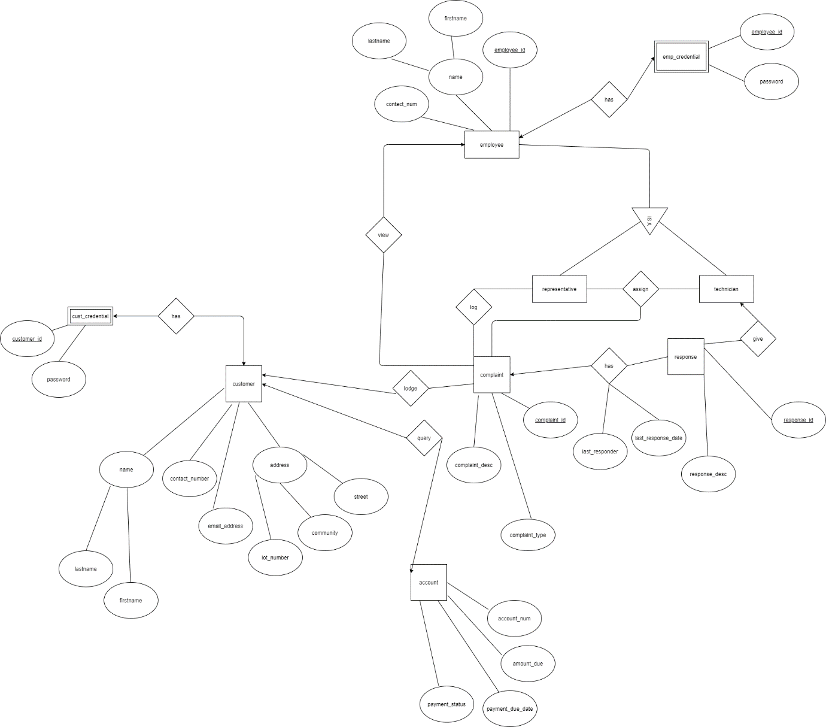

Relational Model

Customer (**Customer_id**, Name(firstname, lastname), Contact_number, Email_addess, Address(lot_number, community, street))

Cust_credential(Password, *customer_id*)

Foreign key: customer_id references Customer

Account (**Account_num**, Amount_due, Payment_due_date, Payment_status)

Complaint (**Complaint_id,** Complaint_type, Complaint_desc)

Response (**Response_id**, Response_desc)

Has (complaint_id, response_id, last_responder, last_response_date)

----------------- ----------------

Foreign key: complaint_id references Complaint

Foreign key: response_id references Response

Employee (**Employee_id**, Name(firstname, lastname), contact_num)

Emp_credential (Password, *employee_id*)

Foreign key: employee_id references Employee

(We understand that representative and technician are two separate entities under employees with different relationships to other entities, we have not seen any specific attributes to create a relational model for them)